**Week-3**

**Skill :- Spring Core and Maven**

**Hands-on 1 :- Exercise 1: Configuring a Basic Spring Application**

Creating a maven project named LibraryManagement

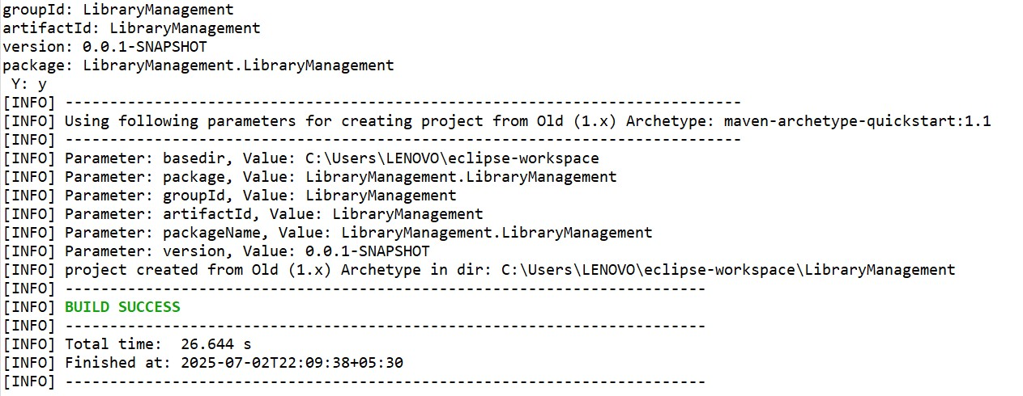

//pom.xml

<project xmlns="http://maven.apache.org/POM/4.0.0"

xmlns:xsi="http://www.w3.org/2001/XMLSchema-instance"

xsi:schemaLocation="http://maven.apache.org/POM/4.0.0

http://maven.apache.org/xsd/maven-4.0.0.xsd">

<modelVersion>4.0.0</modelVersion>

<groupId> LibraryManagement </groupId>

<artifactId>LibraryManagement</artifactId>

<version>1.0-SNAPSHOT</version>

<dependencies>

<!-- Spring Core -->

<dependency>

<groupId>org.springframework</groupId>

<artifactId>spring-context</artifactId>

<version>5.3.36</version>

</dependency>

</dependencies>

</project>

//application.xml

<!-- applicationContext.xml -->

<?xml version="1.0" encoding="UTF-8"?>

<beans xmlns="http://www.springframework.org/schema/beans"

xmlns:xsi="http://www.w3.org/2001/XMLSchema-instance"

xsi:schemaLocation="http://www.springframework.org/schema/beans

http://www.springframework.org/schema/beans/spring-beans.xsd">

<!-- Repository Bean -->

<bean id="bookRepository" class="com.library.repository.BookRepository" />

<!-- Service Bean -->

<bean id="bookService" class="com.library.service.BookService">

<property name="bookRepository" ref="bookRepository"/>

</bean>

</beans>

//bookrepository.java

package com.library.repository;

public class BookRepository {

public void displayBooks() {

System.out.println("Fetching all books from repository...");

} }

//BookService.java

package com.library.service;

import com.library.repository.BookRepository;

public class BookService {

private BookRepository bookRepository;

// Setter Injection

public void setBookRepository(BookRepository bookRepository) {

this.bookRepository = bookRepository;

}

public void listBooks() {

System.out.println("BookService: Listing books...");

bookRepository.displayBooks();

}

}

//MainApp.java

package com.library;

import com.library.service.BookService;

import org.springframework.context.ApplicationContext;

import org.springframework.context.support.ClassPathXmlApplicationContext;

public class MainApp {

public static void main(String[] args) {

// Load Spring Context

ApplicationContext context = new ClassPathXmlApplicationContext("applicationContext.xml");

// Get Bean

BookService bookService = (BookService) context.getBean("bookService");

// Use Service

bookService.listBooks();

}

}

Output:-

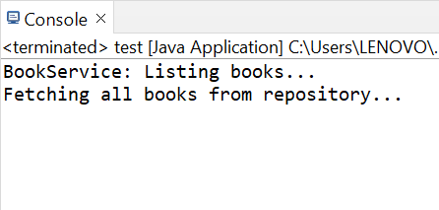

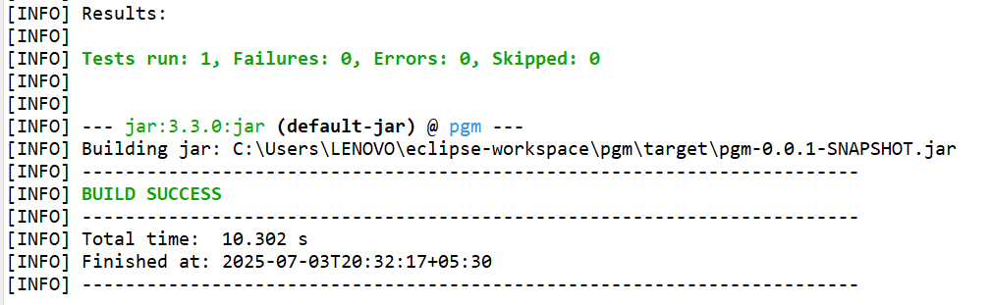

**Hands-on 2 :- Exercise 2: Implementing Dependency Injection**

//BookRepository.java

public class BookRepository {

public void saveBook(String bookName) {

System.out.println("Book saved: " + bookName);

}

}

//BookService.java

public class BookService {

private BookRepository bookRepository;

// Setter Injection

public void setBookRepository(BookRepository bookRepository) {

this.bookRepository = bookRepository;

}

public void addBook(String bookName) {

bookRepository.saveBook(bookName);

}

}

//application.xml

<?xml version="1.0" encoding="UTF-8"?>

<beans xmlns="http://www.springframework.org/schema/beans"

xmlns:xsi="http://www.w3.org/2001/XMLSchema-instance"

xsi:schemaLocation="

http://www.springframework.org/schema/beans

http://www.springframework.org/schema/beans/spring-beans.xsd">

<!-- Define BookRepository bean -->

<bean id="bookRepository" class="BookRepository" />

<!-- Define BookService bean and inject BookRepository -->

<bean id="bookService" class="BookService">

<property name="bookRepository" ref="bookRepository" />

</bean>

</beans>

// LibraryManagementApplication.java

import org.springframework.context.ApplicationContext;

import org.springframework.context.support.ClassPathXmlApplicationContext;

public class LibraryManagementApplication {

public static void main(String[] args) {

ApplicationContext context = new ClassPathXmlApplicationContext("applicationContext.xml");

BookService bookService = (BookService) context.getBean("bookService");

bookService.addBook("The Alchemist");

}

}

Output:-

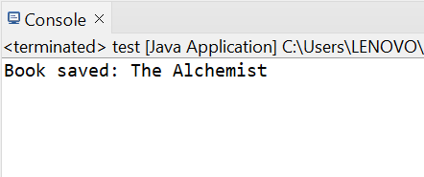

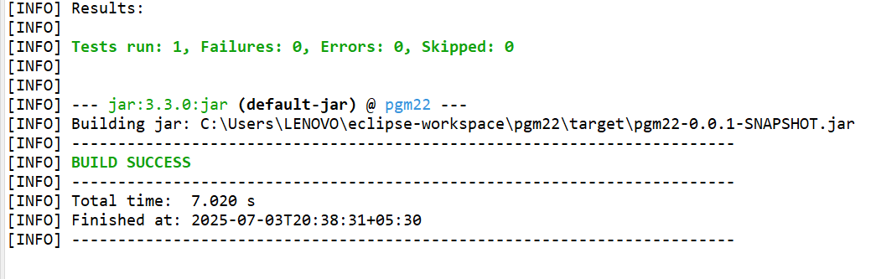

**Hands-on 3:- Exercise 4: Creating and Configuring a Maven Project**

//pom.xml

<project xmlns="http://maven.apache.org/POM/4.0.0"

xmlns:xsi="http://www.w3.org/2001/XMLSchema-instance"

xsi:schemaLocation="http://maven.apache.org/POM/4.0.0

http://maven.apache.org/xsd/maven-4.0.0.xsd">

<modelVersion>4.0.0</modelVersion>

<groupId>com.example</groupId>

<artifactId>LibraryManagement</artifactId>

<version>1.0-SNAPSHOT</version>

<dependencies>

<!-- Spring Core and Context -->

<dependency>

<groupId>org.springframework</groupId>

<artifactId>spring-context</artifactId>

<version>5.3.34</version>

</dependency>

<!-- Spring AOP -->

<dependency>

<groupId>org.springframework</groupId>

<artifactId>spring-aop</artifactId>

<version>5.3.34</version>

</dependency>

<!-- Spring Web MVC -->

<dependency>

<groupId>org.springframework</groupId>

<artifactId>spring-webmvc</artifactId>

<version>5.3.34</version>

</dependency>

<!-- Servlet API for WebMVC (if needed) -->

<dependency>

<groupId>javax.servlet</groupId>

<artifactId>javax.servlet-api</artifactId>

<version>4.0.1</version>

<scope>provided</scope>

</dependency>

</dependencies>

<!-- 3. Configure Maven Compiler Plugin -->

<build>

<plugins>

<plugin>

<groupId>org.apache.maven.plugins</groupId>

<artifactId>maven-compiler-plugin</artifactId>

<version>3.10.1</version>

<configuration>

<source>1.8</source>

<target>1.8</target>

</configuration>

</plugin>

</plugins>

</build>

</project>

Output:-

